EPSC 171A – Fall 2025 – Exercise 3
For this exercise you will use the JMARS program to count the number of craters in two different areas on the Moon and then calculate the ages of those areas (of course, if you are interested in other planets, you are welcome to do the same exercise on another planet; you can email me for that option). Remember we discussed about whether a planetary surface is young or old depending on the densities of craters (Exercise #1). You can download JMARS for free (https://jmars.mars.asu.edu/download). It includes both PC and Mac versions. You don’t have to register for the software. You can just “Login as Guest”. Make Sure you selected “LUNA” in the CELESTIAL BODY of the Login window.
Your responses should be supplied as an electronic file in a format permitting combined text and images (e.g. Word) then converted to pdf format and uploaded to Canvas.
This is exercise 3 of 5. The deadline for upload is 11:59 PM, Wednesday, Oct. 22, 2025.
There’s a user’s guide for this program (https://jmars.mars.asu.edu/crater-counting-layer). It is very intuitive. However, you can watch YouTube tutorials for a quick start:
https://youtu.be/-m-7OvSvuE0
https://youtu.be/6e6q40nNaZE
If you still run into trouble, please feel free to ask for help.
General tips: Add New Layer (Crater Counting). Change the Nomenclature opacity to low (otherwise too many names overlay on the map, making it very difficult to see)
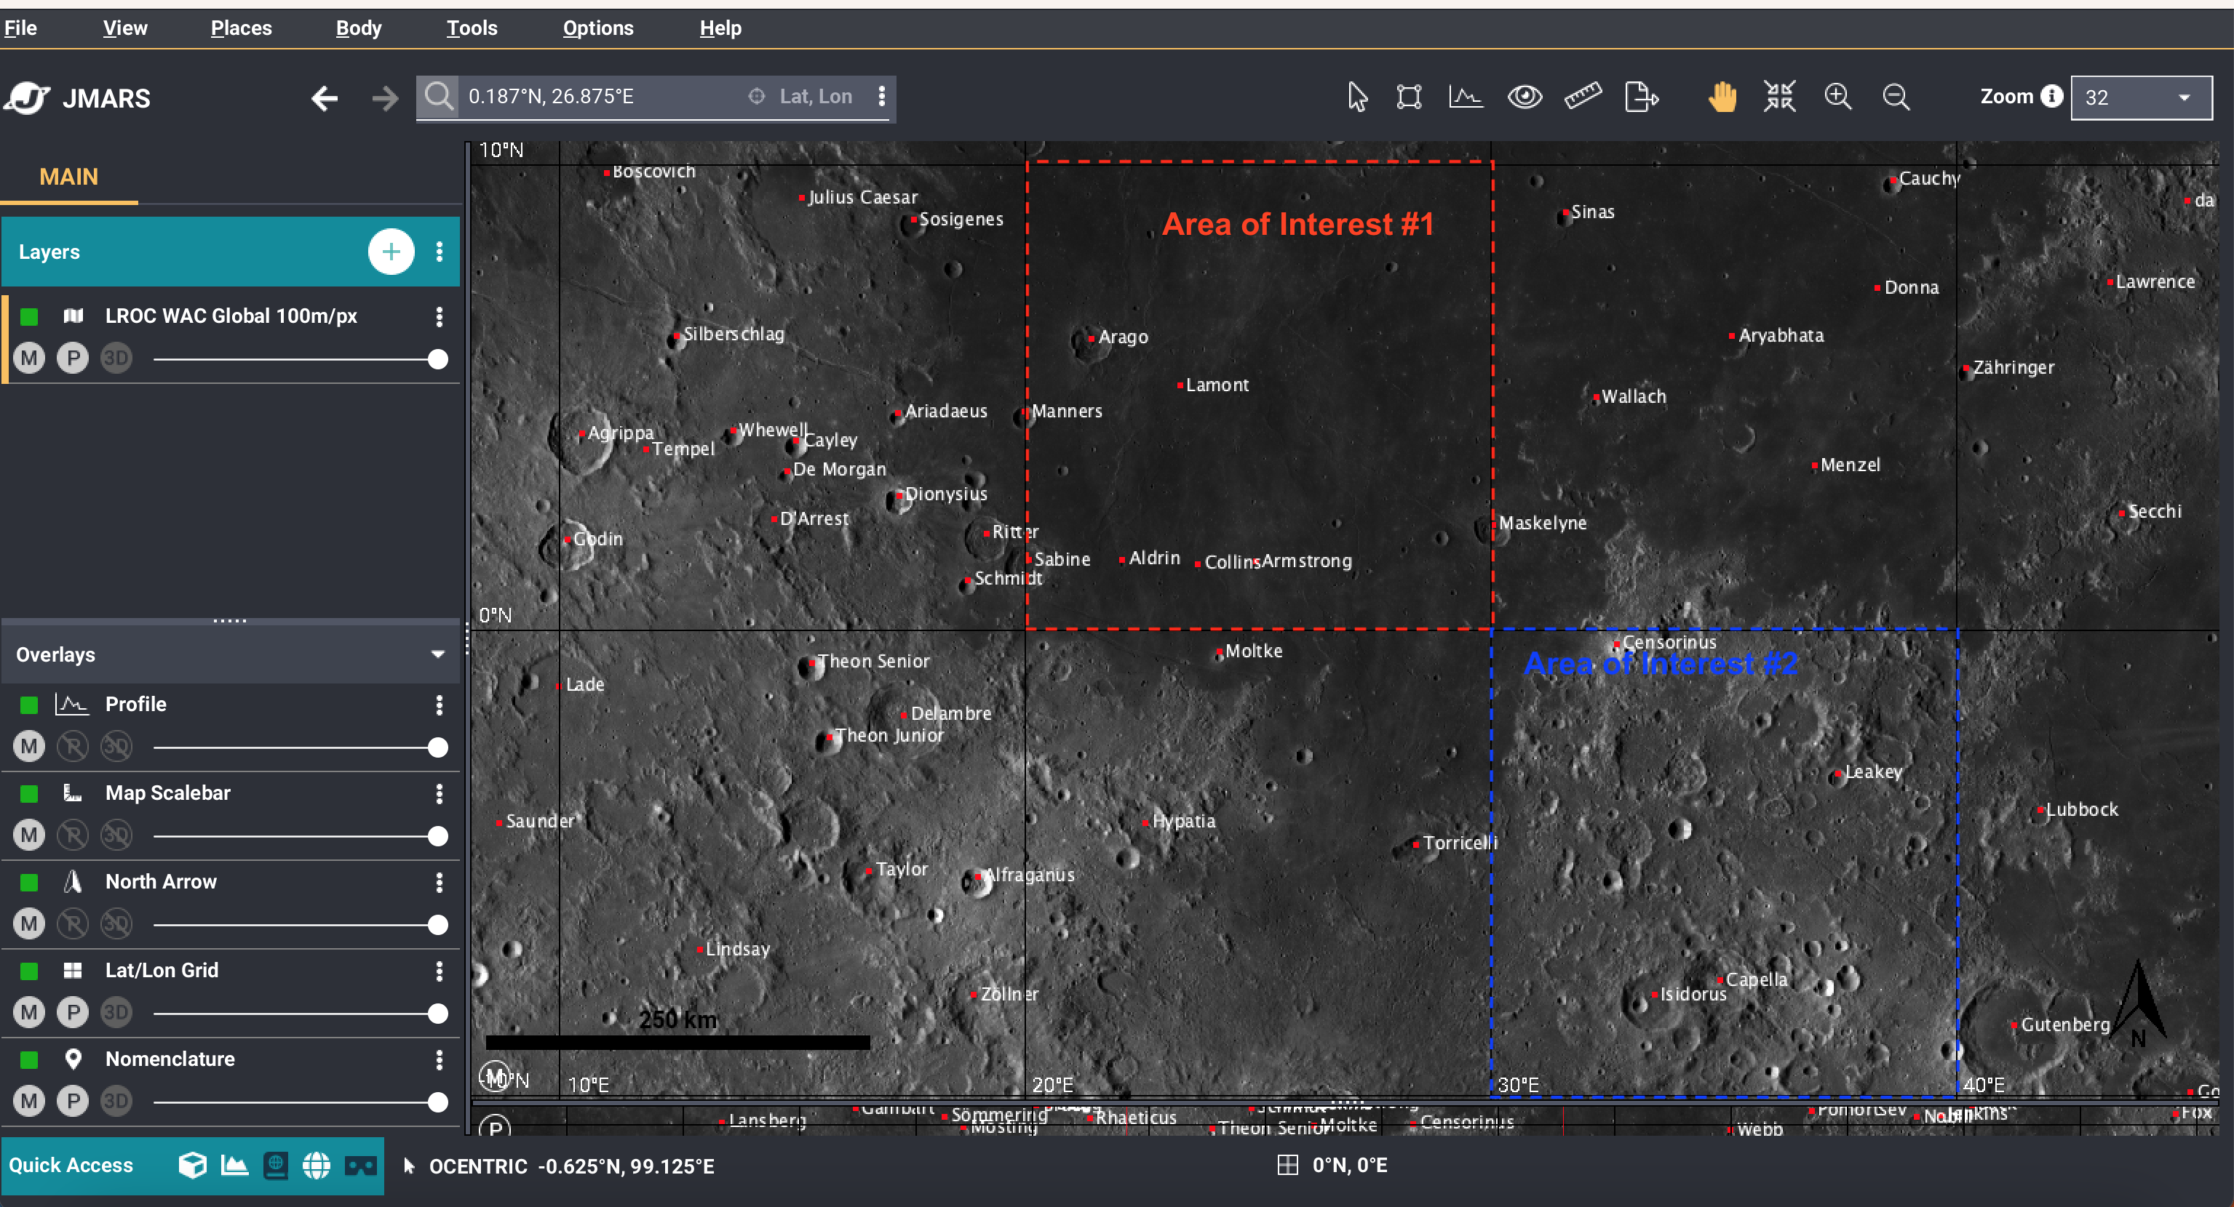

In the “Body” menu, go to “Select Body” and choose “Luna” (the Moon). Go to the Apollo 11 landing site (input coordinates 0.031°N, 23.75°E in the “Lat, Lon” field). If you see the names of the Apollo 11 astronauts (Aldrin, Collins, Armstrong), you are at the right location. In this homework, you will count the numbers of craters in Areas of Interest #1 and #2 (see above image) and answer the questions below. As you can see, AOI #1 is within the smooth and dark mare and AOI #2 is within the rugged and bright highlands terrain. These two areas clearly have different crater densities and thus have different surface ages.
1. Use the crater counting tool provided by JMARS to mark all craters at least 1 km in diameter. Remember to double-click the “Crater Counting” layer to open the “Crater Counting Options”, where you can change the settings (for example, change the “New crater color” to red/yellow, the “New crater diameter” to 1000 m and “Increment Step Size” to 100 m, which will make your life easier). You can adjust the zoom level to make it easier to see the smaller craters. After you count every crater at least 1 km in diameter in AOI #1, double-click the “Crater Counting” layer to open the “Crater Counting Options”. Under the “Craters” tab you can see all these craters you have marked (you can export to Excel to help you count the total numbers).
In total, how many (N) craters in AOI #1 are least 1 km in diameter?
____________
What is the area of AOI #1? (use the ruler in JMARS to measure)
____________km²
The density of craters in AOI #1 is
____________(N/km²)
What is the absolute surface age of AOI #1? Use the Lunar Cratering Chronology Model figure below. Note that the y-axis has a logarithmic scale.
____________Gyr (Giga-years: billion years)
(Note: This is the simplified way to calculate the age. A more sophisticated way to calculate the surface age is to use the Craterstats program to plot isochrons and determine surface ages. However, it requires the use of another software, so it is up to people who are true space enthusiasts to go that route).
2. After you finish with AOI #1, add a new “Crater Counting” layer (otherwise you will add the numbers of craters in AOI #1 to AOI #2 – you need count them separately). Repeat the exercise.
In total, how many (N) craters in AOI #2 are least 1 km in diameter?
____________
What is the area of AOI #2? (use the ruler in JMARS to measure)
____________km²
The density of craters in AOI #2 is
____________(N/km²)
What is the absolute surface age of AOI #2? Use the Lunar Cratering Chronology Model figure below. Note that the y-axis has a logarithmic scale.
____________Gyr (Giga-years: billion years)
Is the highlands area older, or younger, than the mare area? ____________
What is the difference in ages of the two surfaces? ____________Gyr (billion years)
Please take a screen shot of your JMARS to show either AOI#1 or AOI#2 with the marked craters (It is not possible for two people having the same screenshot since everyone counts in slightly different way)
After you finished the homework, you can watch this video. You will see that even experts of cratering counting (many of them graduated from WashU) get numbers very different from each other.
https://youtu.be/fGQF2-G4jNw
https://source.wustl.edu/2014/03/whats-so-hard-about-counting-craters/

